Lab no:04

Objective: To learn report generation in OLTP systems

Lab tasks

Generate an OLTP system report which displays the following results:

1. **Total sales in a month** (Use only order table).
2. **Profit/loss in a month** (Use product (to account for purchasing costs), expenditure as well as order tables).
3. **Highest selling product of the month** (By highest sold quantity)
4. **Lowest selling product of the month** (By lowest sold quantity)

Expenditure Table:

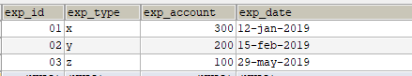

Order Table:

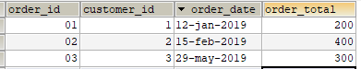

Order details:

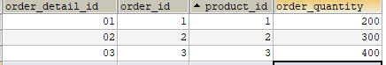

Product:

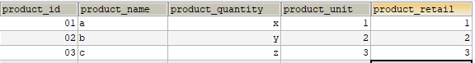

Stored procedure:

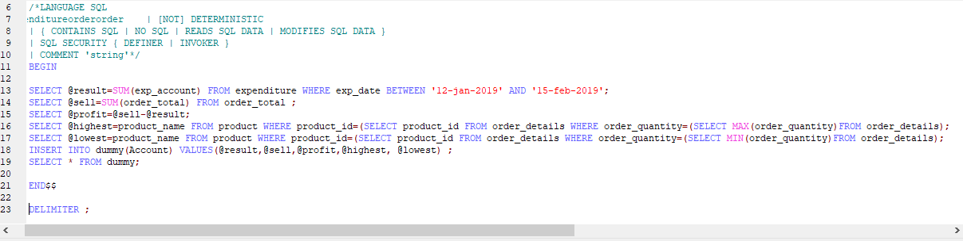

Output:

